if((i+j+k)%2==0)

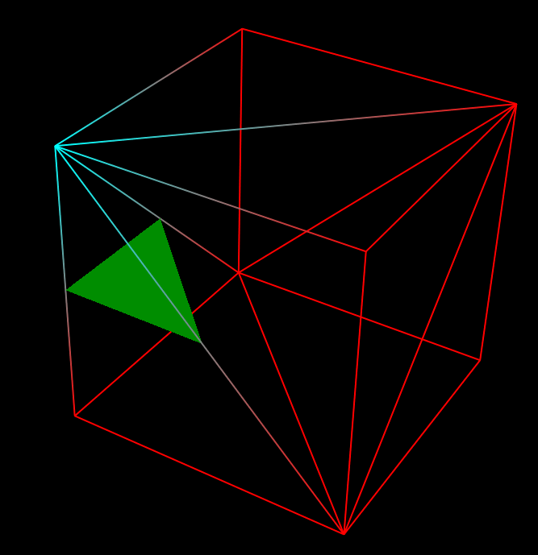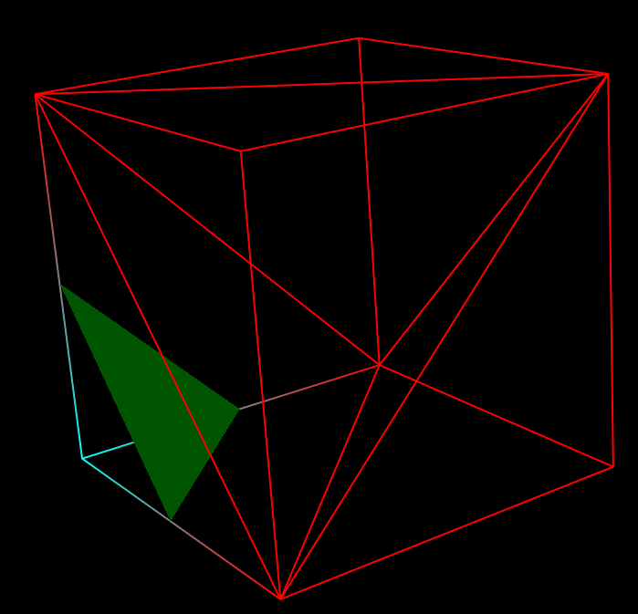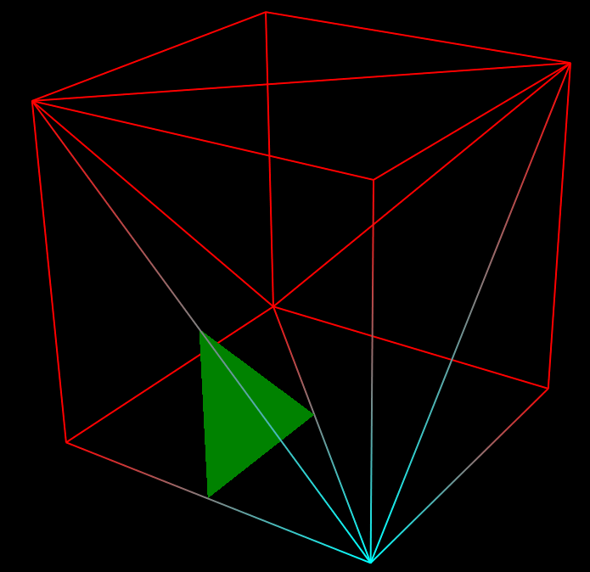

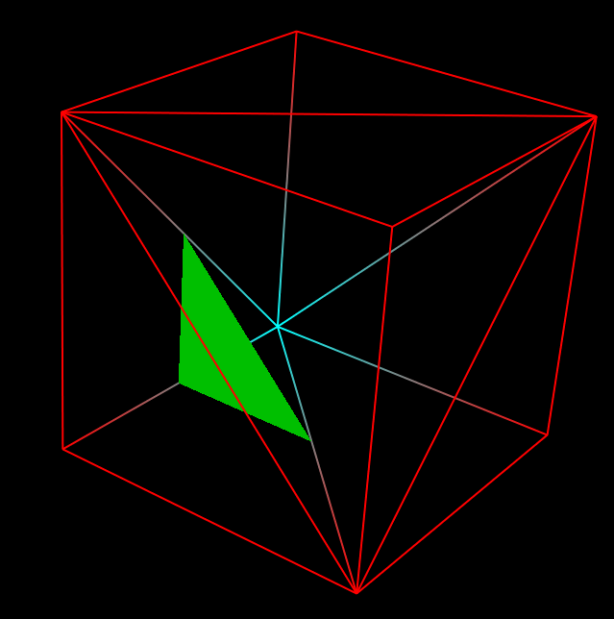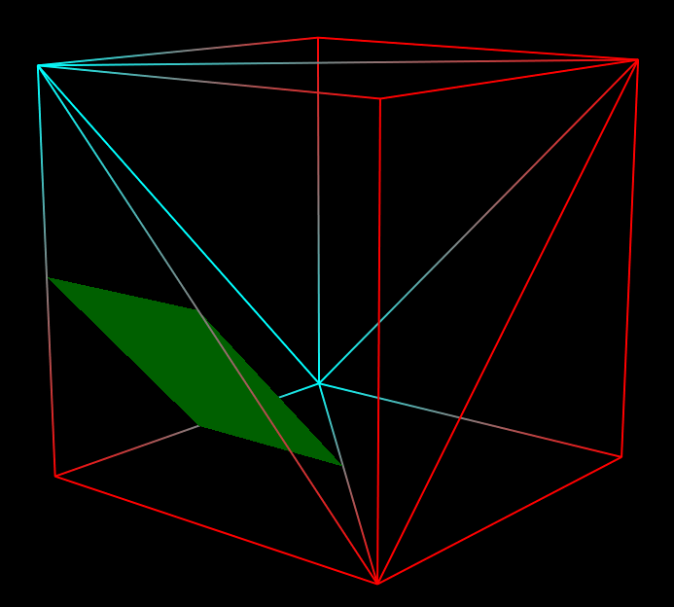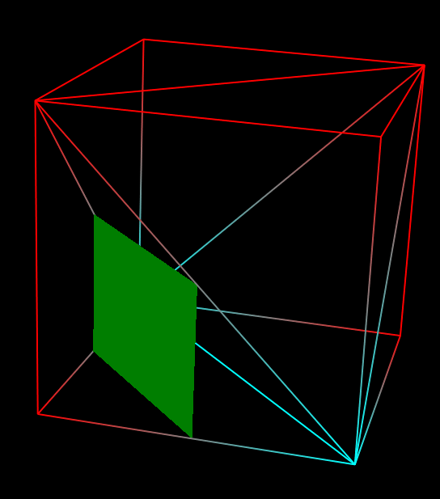

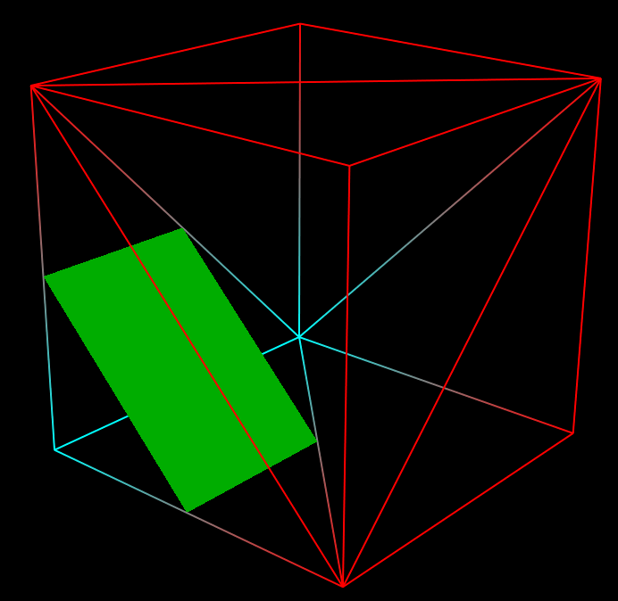

**if(frontEdgeCoordinateIndices[k][i+1][j]!=-1&&frontCenterEdgeCoordinateIndices[k][i+1][j]!=-1&&leftCenterEdgeCoordinateIndices[k][i][j]!=-1)c+=6;**

**else if(frontEdgeCoordinateIndices[k][i+1][j]!=-1&&upEdgeCoordinateIndices[k][i+1][j]!=-1&&leftEdgeCoordinateIndices[k][i][j]!=-1)c+=6;**

**else if(upEdgeCoordinateIndices[k][i+1][j]!=-1&&frontCenterEdgeCoordinateIndices[k][i+1][j]!=-1&&upCenterEdgeCoordinateIndices[k][i][j]!=-1)c+=6;**

**else if(upCenterEdgeCoordinateIndices[k][i][j]!=-1&&leftCenterEdgeCoordinateIndices[k][i][j]!=-1&&leftEdgeCoordinateIndices[k][i][j]!=-1)c+=6;**

**elseif(frontEdgeCoordinateIndices[k][i+1][j]!=-1&&frontCenterEdgeCoordinateIndices[k][i+1][j]!=-1&&upCenterEdgeCoordinateIndices[k][i][j]!=-1&&leftEdgeCoordinateIndices[k][i][j]!=-1)c+=12;**

**elseif(frontCenterEdgeCoordinateIndices[k][i+1][j]!=-1&&leftCenterEdgeCoordinateIndices[k][i][j]!=-1&&leftEdgeCoordinateIndices[k][i][j]!=-1&&upEdgeCoordinateIndices[k][i+1][j]!=-1)c+=12;**

**elseif(leftCenterEdgeCoordinateIndices[k][i][j]!=-1&&frontEdgeCoordinateIndices[k][i+1][j]!=-1&&upEdgeCoordinateIndices[k][i+1][j]!=-1&&upCenterEdgeCoordinateIndices[k][i][j]!=-1)c+=12;else b++;**